Abstract

The rapid digitization of professional services has transformed the way legal consultations are delivered, creating opportunities for more accessible and efficient client–lawyer interactions. This project proposes the development of a Virtual Legal Advisory and Case Management System, a real-time digital portal designed to streamline legal services through secure virtual appointments, case tracking, and document management. Built on the MERN stack, the platform leverages WebRTC to enable seamless video consultations between clients and legal advisors. Clients can securely upload legal documents in PDF format, track the status of their cases, and receive automated email reminders for appointments and case updates. The system ensures authentication and role-based access using JWT (JSON Web Tokens), while an admin dashboard facilitates oversight of user activity, appointments, and compliance. By integrating video conferencing, document handling, and real-time case management into a single platform, the system reduces geographical barriers, minimizes paperwork, and enhances transparency. This solution has the potential to modernize traditional legal services, providing a more efficient, secure, and client-friendly approach to legal advisory and case management.
Keywords : Virtual Legal Advisory, Case Management System, Real- Time Consultation, WebRTC, MERN Stack, JWT Authentication.

CHAPTER – I
INTRODUCTION

The legal industry is one of the oldest and most traditional professions, deeply rooted in manual processes, in-person consultations, and physical documentation. However, with the advancement of digital technologies and the increasing demand for online services, there is a pressing need to modernize how legal services are delivered and consumed. In recent years, digitization has reshaped various domains such as healthcare, finance, and education, and the legal sector is beginning to experience a similar transformation. A Virtual Legal Advisory and Case Management System provides a framework for bridging the gap between lawyers and clients by leveraging real-time digital tools for legal consultations, case tracking, and secure document management.
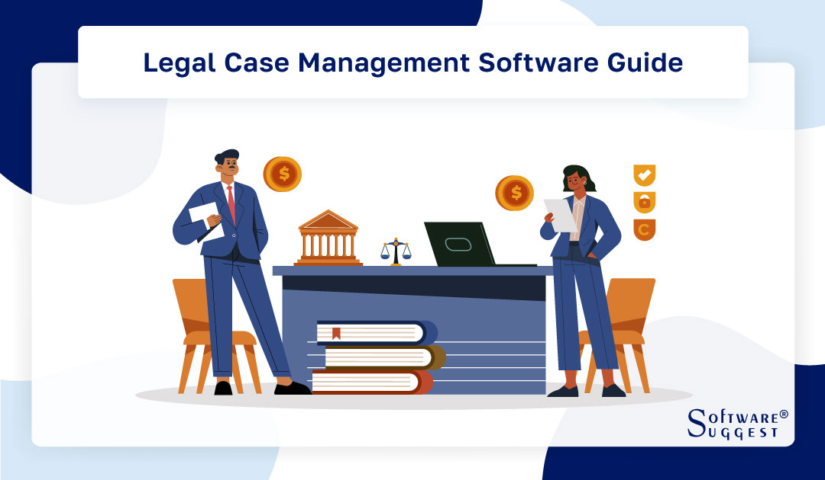

The traditional legal consultation process often involves physical visits to law offices, manual document submission, and repetitive communication delays. These barriers make legal assistance expensive, time-consuming, and inaccessible to many individuals, particularly those in remote areas. Moreover, the reliance on physical records introduces risks such as loss, mismanagement, and confidentiality breaches. To address these issues, the integration of modern information and communication technologies (ICTs) into the legal industry is both necessary and timely. By creating a digital platform where lawyers and clients can connect seamlessly, legal services can become more efficient, transparent, and inclusive.
The emergence of web technologies and cloud-based solutions has enabled the development of online platforms that go beyond simple communication tools. With the use of frameworks such as the MERN stack (MongoDB, Express.js, React.js, and Node.js), it becomes possible to build scalable and interactive platforms capable of handling large amounts of legal data, documents, and consultations. These technologies empower the system to deliver user-friendly interfaces, efficient database operations, and secure transactions, making it an ideal choice for building an online legal advisory portal.
One of the core innovations in this system is the inclusion of real-time video consultations powered by WebRTC. Legal consultations often require nuanced discussions that cannot be fully addressed through text or email communication alone. WebRTC enables encrypted peer-to-peer video communication directly from a web browser without the need for third-party plugins, thus allowing lawyers and clients to interact virtually as if in a face-to-face consultation. This ensures that clients receive professional guidance instantly while reducing travel costs and delays associated with in-person meetings.
The platform further incorporates secure document management, which is critical in the legal industry where contracts, affidavits, evidence, and case files form the backbone of client–lawyer interactions. By supporting PDF uploads, the system ensures standardized document handling while maintaining compatibility across devices and platforms. These documents are stored securely, with access restricted through role-based authentication, ensuring that sensitive client data remains confidential and protected against unauthorized access.
Another vital feature of the system is case tracking, which allows clients to monitor the progress of their cases in real time. Traditionally, clients depend on phone calls, emails, or office visits to stay updated on case proceedings, which often leads to communication gaps and frustration. Through this digital portal, clients can view case milestones, hearing schedules, and lawyer updates directly from their dashboard. This improves transparency and builds trust in the client–lawyer relationship by ensuring that clients are always informed about the status of their cases.
The system also integrates JWT (JSON Web Tokens) for authentication and secure role-based access control. In the legal domain, maintaining confidentiality and preventing unauthorized access to documents and consultations is paramount. JWT provides a lightweight and stateless mechanism for authentication, ensuring that each user session is secure while reducing the overhead associated with managing traditional session-based authentication systems. By assigning roles (e.g., client, lawyer, administrator), the platform ensures that each user has access only to the functionalities and data relevant to their role.
An admin dashboard forms another cornerstone of the platform, offering a comprehensive overview of users, appointments, and documents. Administrators can monitor system activities, ensure compliance with legal data standards, and intervene when necessary to resolve disputes or technical issues. This centralized control not only enhances security but also ensures accountability and smooth operation of the platform.
To further enhance the user experience, the system includes automated email reminders for consultations and case updates. Missed appointments and communication delays are common challenges in legal services, often leading to inefficiencies and dissatisfaction. By sending timely reminders, the platform ensures better coordination between clients and lawyers while reducing the likelihood of missed deadlines or hearings. This feature reflects the platform’s emphasis on professionalism, efficiency, and client satisfaction.
The COVID-19 pandemic significantly accelerated the shift toward virtual services, with courts, law firms, and legal institutions forced to adapt to remote operations. This period highlighted the vulnerabilities of traditional systems and demonstrated the potential of digital solutions to maintain continuity in legal services. Even in the post-pandemic era, the demand for virtual consultations continues to grow, as clients increasingly prefer the flexibility and convenience offered by online platforms. The proposed system is well-positioned to address this demand by combining real-time communication, secure document handling, and efficient case management.
From a broader perspective, the platform contributes to the digitization of justice systems, which aligns with global efforts to increase access to justice and reduce inequalities. Many individuals, especially those in rural or underserved areas, face significant challenges in accessing legal support due to geographical, financial, or social constraints. By providing a secure and user-friendly digital portal, this system democratizes access to legal services, empowering individuals who might otherwise struggle to engage with the legal system.
In addition to serving clients, the system also provides significant benefits to lawyers and legal practitioners. Managing multiple clients, cases, and documents can be overwhelming in a traditional setting. Through features such as automated scheduling, centralized case management, and digital record keeping, the system helps lawyers streamline their workflows, reduce administrative burdens, and focus more on providing quality legal advice. This not only improves efficiency but also enhances the overall client experience.
The use of the MERN stack ensures that the platform is highly scalable and adaptable to future enhancements. MongoDB provides a flexible schema for storing diverse legal data, Express.js and Node.js handle robust backend services, and React.js delivers a responsive and interactive frontend. Together, these technologies ensure that the system can handle increasing volumes of users, documents, and consultations without compromising performance or security.
From a security standpoint, the platform is designed with data protection and confidentiality as top priorities. The legal industry deals with highly sensitive information, and any data breach could have severe consequences for both clients and legal practitioners. By integrating secure file handling, encrypted video communication, and JWT-based authentication, the system adheres to modern cybersecurity standards and ensures that user trust is maintained.
The implementation of such a system also paves the way for integration with other digital legal services, such as e-signatures, online payment gateways, and legal research tools. These integrations could further enhance the platform’s utility, making it a one-stop solution for all legal advisory and case management needs. By starting with core features like video consultation, document management, and case tracking, the platform lays a solid foundation for future expansions.
Moreover, the platform holds significant potential in academic and training contexts, where law schools and institutions can use it to simulate real-world client–lawyer interactions. Students can practice virtual consultations, upload mock legal documents, and track case progress, thereby gaining practical exposure to digital legal practice. This contributes to preparing the next generation of lawyers for a digital-first world.
The introduction of this system also aligns with the broader movement towards digital governance and smart justice systems. Governments and legal institutions worldwide are increasingly investing in digital platforms to improve efficiency, reduce backlog, and make justice more accessible. By providing a model for a secure and scalable legal advisory system, this project demonstrates how technology can complement existing legal infrastructures and contribute to systemic reforms.
In essence, the proposed Virtual Legal Advisory and Case Management System combines innovation, security, and accessibility to address the shortcomings of traditional legal consultation methods. By integrating modern web technologies with domain-specific requirements of the legal sector, the system delivers a holistic solution that benefits clients, lawyers, and administrators alike.
The legal industry has historically relied on face-to-face interactions, extensive paperwork, and traditional courtroom procedures. While this approach has served society for decades, it also presents inefficiencies in terms of accessibility, affordability, and time management. Clients often struggle with scheduling consultations, traveling to legal offices, and keeping track of case progress or legal documents. Lawyers, on the other hand, face difficulties in managing multiple clients, securely storing sensitive information, and providing timely updates. In an era where digital transformation has touched almost every domain—education, healthcare, banking, and governance—it has become imperative for the legal sector to embrace technology-driven solutions. This need forms the basis for the Virtual Legal Advisory and Case Management System, which seeks to revolutionize the way clients and lawyers interact.
A virtual legal platform leverages modern technologies to provide real-time communication, efficient document management, and seamless case tracking. Instead of relying on physical presence, the system enables clients to consult with lawyers through WebRTC-based video conferencing, ensuring instant access to professional legal advice from any location. For many individuals, particularly those in rural or underserved areas, this can be a game-changer, removing geographical barriers that traditionally hinder access to justice. By embedding case management and secure document handling within the platform, the system addresses one of the most pressing concerns in the legal domain—the secure and organized handling of confidential legal records.
The rise of the internet and cloud-based solutions has transformed expectations in terms of service delivery. Clients now expect the same level of convenience from legal services as they do from e-commerce, online banking, or telemedicine. The Virtual Legal Advisory System fits perfectly into this paradigm shift by offering a centralized portal where clients can book appointments, upload relevant case documents in PDF or digital format, and receive real-time updates about their case progress. From the lawyer’s perspective, the system allows for better workload management, automated reminders, and streamlined communication with clients. This ultimately enhances both efficiency and client satisfaction.
Moreover, the system addresses a critical challenge in the legal profession—time management. Traditional legal consultations often involve multiple visits, scheduling conflicts, and lengthy communication chains. By digitizing the process, the platform cuts down unnecessary delays and provides a structured workflow. Lawyers can schedule virtual consultations, review uploaded documents before meetings, and maintain an organized timeline of the case history. This systematic approach not only saves time but also enhances the quality of service, as lawyers can dedicate more focus to the actual legal strategy rather than administrative burdens.
From a technological standpoint, the system utilizes the MERN stack (MongoDB, Express.js, React.js, Node.js) to ensure a scalable, robust, and user-friendly platform. MongoDB provides a flexible schema to store structured and unstructured case-related data, Express.js and Node.js handle server-side operations with speed and reliability, while React.js delivers an interactive and intuitive front-end interface for both clients and lawyers. Integration of JWT (JSON Web Token) ensures secure authentication and authorization, preventing unauthorized access to sensitive legal records. This technological choice not only guarantees performance but also aligns with modern full-stack development practices that enable real-time, cloud-based applications.
One of the most valuable components of this system is the video consultation feature, powered by WebRTC. Unlike traditional video conferencing apps, WebRTC provides peer-to-peer communication within the browser, ensuring low-latency, secure, and reliable video calls without the need for external plugins. This technology brings immediacy and accessibility to legal services, bridging the communication gap between lawyers and clients. Combined with features such as document sharing during calls and screen-sharing for contract reviews, the system enhances the consultation process and mirrors the experience of a physical face-to-face meeting.
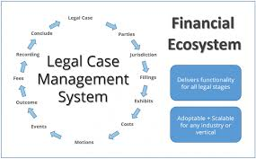
Legal documentation is often one of the most complex and error-prone aspects of case management. Misplaced files, duplication, or unorganized document storage can severely impact case outcomes. To solve this, the platform incorporates a digital document management system where clients can upload case-related PDFs, contracts, or affidavits. These documents are then stored securely, categorized properly, and made available for review anytime by the respective lawyer. Moreover, version control mechanisms and audit trails ensure that the integrity of legal files is maintained at all times. This digital-first approach ensures that both clients and lawyers have a single source of truth for all case-related information.

An equally important feature is case tracking, which provides clients with transparency about the current status of their legal proceedings. Instead of repeatedly contacting their lawyers for updates, clients can log in to the system and view progress markers such as "Case Filed," "Under Review," "Hearing Scheduled," "In Progress," or "Closed." For lawyers, this provides a workflow management tool that helps them keep track of deadlines, upcoming hearings, and pending documentation. Such transparency not only builds trust but also fosters better collaboration between clients and lawyers.
Another dimension of the system is the admin dashboard, which serves as a central monitoring and control hub. The admin plays a key role in managing user registrations, ensuring compliance with legal ethics, and monitoring data security. With integrated analytics, the dashboard can also provide insights into system usage—such as the number of consultations conducted, common case types, and peak usage times. This enables better decision-making for platform improvements and scaling. Moreover, the admin can intervene in disputes, ensure smooth onboarding of legal professionals, and monitor the overall health of the system.
The inclusion of email reminders and notifications adds an extra layer of efficiency to the system. Clients can receive alerts about upcoming consultations, deadlines for document submission, or case progress updates. Lawyers can receive reminders about scheduled hearings, client meetings, or pending case notes. This proactive communication ensures that no critical step in the legal process is missed, reducing the likelihood of delays or miscommunication. Additionally, by automating reminders, the system reduces manual administrative effort, allowing legal professionals to focus more on substantive casework.
Security and confidentiality form the backbone of this platform. Since legal records often contain sensitive personal and financial information, the system is built with end-to-end encryption, role-based access control, and secure file handling mechanisms. JWT tokens ensure that only authenticated users can access the platform, while data encryption techniques safeguard stored and transmitted data. By adhering to strict security standards, the system builds confidence among clients, encouraging them to adopt digital legal services without hesitation.
At the same time, the system empowers clients by making legal services more accessible and affordable. Traditionally, legal consultations are not only time-consuming but also costly due to travel and administrative overheads. By shifting consultations online, clients can save both time and money while still receiving high-quality professional advice. This democratization of legal services ensures that even individuals with limited financial means or those living in remote areas can access justice on par with urban populations.
The introduction of a virtual platform for legal advisory also aligns with global trends in digital justice initiatives. Many governments and legal authorities are now embracing e-courts, digital filings, and online arbitration. By building such a system, we are not only meeting the current demand but also future-proofing the legal ecosystem against disruptions such as pandemics or natural disasters, where physical meetings may not be possible. The system thus acts as a critical enabler for resilient and adaptive legal services.
Furthermore, the platform enhances professional growth opportunities for lawyers. By registering on the portal, legal professionals can expand their client base beyond geographical boundaries, thereby opening up new avenues for practice. For new lawyers, this system provides visibility and access to clients that may otherwise have been restricted to established practitioners with physical offices. This creates a level playing field in the legal industry, fostering inclusivity and innovation.
Another significant benefit is the environmental impact of digitizing legal services. By reducing the reliance on paper documentation, physical travel, and office space, the platform contributes to sustainability goals. As the world increasingly focuses on reducing carbon footprints, digital platforms like this support the legal industry’s transition toward more eco-friendly practices.
The global legal industry is undergoing a rapid transformation driven by advancements in digital technologies and the increasing need for accessible and affordable legal services. Traditional legal systems, while robust and time-tested, are often perceived as expensive, time-consuming, and geographically constrained. Clients frequently struggle with scheduling in-person appointments, managing bulky case files, and following up on court proceedings. A virtual legal advisory and case management system seeks to bridge these gaps by providing an integrated digital platform that enables clients to connect with lawyers remotely, upload and access case documents, and track the progress of their legal matters in real time. By doing so, it ensures that legal services are no longer bound by physical offices and limited consultation hours, but instead are available anytime and anywhere, empowering both clients and lawyers alike.
The development of such a system has been accelerated by the global shift towards digital solutions during the COVID-19 pandemic, which emphasized the importance of remote service delivery. Just as telemedicine has revolutionized healthcare by allowing patients to consult with doctors online, virtual legal platforms are redefining how individuals interact with legal professionals. Clients no longer need to travel long distances to meet a lawyer, reducing not only the costs associated with transportation but also the stress and delays that come with scheduling conflicts. This convenience has made digital consultation platforms highly appealing to both urban and rural populations, particularly in regions where access to legal professionals is scarce. By integrating technologies such as WebRTC for secure video consultations, the proposed system makes legal advice more interactive, personal, and efficient.
Another significant advantage of this system is the streamlined case management process. In traditional setups, clients often face difficulties in maintaining physical records, retrieving old case files, and securely sharing sensitive documents with their lawyers. A virtual case management system digitizes this entire process, enabling users to upload, categorize, and retrieve legal documents on demand. Furthermore, built-in encryption and secure authentication protocols ensure that sensitive client data remains confidential and inaccessible to unauthorized entities. For lawyers, this digital repository enhances productivity, allowing them to manage multiple cases from a centralized dashboard while minimizing the risk of misplacing important records.
The system also addresses one of the most common issues in the legal sector—delayed communication. Many clients report frustration due to a lack of timely updates on their ongoing cases. Through automated notifications, email reminders, and real-time tracking features, the platform ensures that clients remain well-informed about their case progress, court dates, and lawyer feedback. This transparency builds trust between clients and legal practitioners, reducing misunderstandings and fostering stronger professional relationships. It also empowers clients to be active participants in their legal journey rather than passive observers.
From a technical standpoint, the choice of the MERN stack—MongoDB, Express.js, React.js, and Node.js—provides a robust foundation for developing such a platform. MongoDB ensures scalable and flexible data management, allowing for the storage of diverse legal documents and case histories. Express.js and Node.js power the backend, handling authentication, real-time communication, and API integrations seamlessly. React.js, on the other hand, enables the development of an intuitive, user-friendly interface that caters to both tech-savvy and non-technical users. Together, these technologies create a powerful ecosystem capable of handling high user loads, ensuring smooth performance, and offering future scalability.
In addition to standard functionalities, the inclusion of WebRTC technology introduces a layer of real-time communication essential for legal consultations. Unlike traditional phone calls or email exchanges, WebRTC allows face-to-face video interaction between clients and lawyers, fostering trust and enhancing the quality of consultations. Video consultations make it easier for lawyers to assess the seriousness of a case and for clients to feel more engaged in the process. Combined with screen-sharing and document-sharing capabilities, WebRTC transforms the platform into a true digital courtroom, albeit in a simplified and client-friendly format.
A key component of the system is security. Legal matters often involve highly sensitive and confidential information, ranging from personal identification details to financial records and legal strategies. As such, the platform must incorporate advanced security measures, including end-to-end encryption, role-based access control, and secure authentication via JWT (JSON Web Tokens). These features protect user accounts, safeguard communication channels, and ensure that only authorized individuals can access confidential data. By integrating these security protocols, the system not only adheres to data protection laws such as GDPR but also builds confidence among clients who may be hesitant to adopt digital solutions.
Another crucial aspect of the system is the admin dashboard, which enables effective oversight and management. Administrators can monitor lawyer performance, track the number of consultations, ensure compliance with legal standards, and address client grievances promptly. This centralized control mechanism prevents misuse, ensures quality service delivery, and supports accountability. For instance, if a lawyer consistently fails to attend consultations or deliver timely updates, the admin can intervene, thereby maintaining the overall reliability of the platform.
The system also supports email and notification reminders to minimize missed appointments. Clients are often overwhelmed with work, family responsibilities, or ongoing legal stress, which can cause them to forget important dates. Automated reminders for consultations, court appearances, or document submissions ensure that such oversights do not jeopardize their cases. Lawyers too benefit from reminders that help them stay on top of deadlines and commitments, ultimately improving the efficiency of the legal process.
On a societal level, the platform addresses the issue of legal accessibility. In many developing countries, rural populations lack adequate legal infrastructure, forcing individuals to travel to cities or rely on intermediaries for legal services. This often results in exploitation, misinformation, or complete denial of justice. A digital platform can democratize legal services by bridging the gap between urban lawyers and rural clients, ensuring that geographical location is no longer a barrier to justice. Such inclusivity promotes fairness, reduces inequality, and strengthens the rule of law.
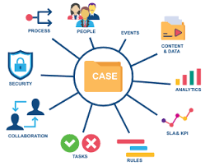
Furthermore, the virtual legal advisory and case management system holds immense potential for integration with emerging technologies. Artificial Intelligence (AI) and Machine Learning (ML) can be leveraged to provide predictive case outcomes, automated document review, and intelligent lawyer-client matching based on case type. For instance, AI could analyze previous case histories and legal precedents to offer lawyers data-driven insights, thereby improving the accuracy and speed of legal decision-making. Chatbots powered by natural language processing could also handle preliminary client queries, reducing the workload of lawyers and improving user experience.

However, despite its numerous benefits, the platform must also address challenges such as digital illiteracy, resistance to change, and internet accessibility. Many clients, particularly from older generations or underserved regions, may not be familiar with using online platforms. Hence, the system should include user education, tutorials, and multilingual support to accommodate diverse users. Similarly, robust offline functionality and mobile-first design can help users with limited or unstable internet connections access services effectively.
From an economic perspective, the platform can create new opportunities for legal professionals. Lawyers can expand their client base beyond geographical limitations, increasing their earnings and visibility. At the same time, clients benefit from competitive pricing models, as digital platforms reduce overhead costs compared to traditional law firms. Subscription-based plans, pay-per-consultation models, or tiered service packages could be introduced to cater to different client segments, making legal services more affordable and flexible.
Another important implication of the system is its role in maintaining digital records that can be used for future reference and audits. Courts and legal institutions often require detailed documentation of case progress, lawyer interactions, and client communications. The digital system can generate comprehensive logs and reports that not only aid in case tracking but also serve as evidence of due diligence and accountability. Over time, this builds a transparent ecosystem where malpractice is minimized, and justice is delivered more effectively.
In the context of globalization, such platforms can also foster cross-border legal consultations. With increasing international trade, migration, and cross-border disputes, clients often require legal expertise from multiple jurisdictions. A virtual advisory system can connect clients with lawyers licensed in different countries, facilitating seamless collaboration and helping clients navigate complex international legal frameworks.
Additionally, the platform can serve as an educational tool for clients, offering access to legal resources, FAQs, and knowledge bases. By improving legal literacy, the system empowers clients to make informed decisions and reduces the risk of exploitation by unethical practitioners. This educational component, combined with professional legal consultations, ensures a holistic approach to delivering justice.
The system also contributes to environmental sustainability by reducing the reliance on physical paperwork and in-person meetings. By digitizing legal documents and minimizing travel, it helps reduce carbon emissions and paper waste, aligning the legal industry with global sustainability goals. This green dimension not only benefits the environment but also enhances the reputation of the platform among eco-conscious users.
The emergence of digital transformation has fundamentally altered how professional services are delivered across industries. Healthcare witnessed the rise of telemedicine, education embraced e-learning platforms, and banking migrated toward digital transactions. The legal profession, while traditionally resistant to rapid change due to its reliance on precedence, confidentiality, and ethics, is now being compelled to adapt. Clients are increasingly demanding legal services that are not only competent but also convenient and time-efficient. The proposed Virtual Legal Advisory and Case Management System directly responds to this evolving landscape, positioning itself as a catalyst for modernization in the legal sector.
One of the most critical drivers for this transformation is the increasing complexity of modern legal cases. With globalization, cross-border commerce, and rapidly evolving regulatory frameworks, both individuals and businesses are constantly in need of timely legal advice. A delay in receiving consultation can lead to financial penalties, reputational loss, or even denial of justice. Traditional systems often struggle to keep up with such dynamic needs due to their dependence on physical presence and paper-based workflows. A cloud-powered legal advisory system can bridge this gap by offering instant consultations, centralized case data, and real-time tracking, ensuring that legal services remain relevant and effective in a fast-paced world.
Another key aspect is the digital behavior of modern clients. Today’s generation is accustomed to using apps for almost everything—food delivery, online shopping, health consultations, and education. It is only natural that they expect the same seamless digital experience in legal services. A platform that offers user-friendly interfaces, one-click appointment booking, secure uploads, and video calls can significantly improve client satisfaction. By meeting clients where they are—online—the system ensures higher engagement rates and long-term trust-building. This shift from traditional office-based interactions to on-demand, technology-driven consultations is not just a convenience but a necessity for the modern era.
The system also addresses the longstanding challenge of rural and remote accessibility. In many developing countries, a large portion of the population resides in areas with limited or no access to professional legal assistance. Traveling to metropolitan cities for legal advice often involves considerable expenses and logistical barriers. The Virtual Legal Advisory platform eliminates this obstacle by providing remote consultation capabilities. With just a smartphone or computer and internet connection, clients in the remotest corners can access high-quality legal services, thereby fostering inclusivity and bridging the urban-rural divide in justice delivery.
Equally important is the issue of transparency in legal practice. Clients often complain about being left in the dark regarding the status of their cases, timelines, or the next steps. This lack of communication erodes trust and can even discourage individuals from seeking justice. By incorporating real-time case tracking, automated notifications, and direct communication channels, the system ensures that clients remain informed at every stage of their legal journey. Transparency not only builds confidence but also empowers clients to make better decisions, ultimately enhancing the credibility of legal practitioners.
From the perspective of legal professionals, this system acts as a powerful productivity tool. Lawyers often juggle multiple cases simultaneously, each with its unique deadlines, hearings, and document requirements. Manual tracking and fragmented communication channels lead to missed opportunities and administrative overload. By offering a centralized dashboard, calendar integrations, and automated reminders, the platform reduces routine overhead, enabling lawyers to focus on core activities such as research, strategy formulation, and advocacy. In the long run, such productivity enhancements translate into higher client satisfaction, professional growth, and financial success for lawyers.
The integration of document management within the platform also resolves several inefficiencies in traditional practices. Legal documents are often extensive, repetitive, and require multiple versions as a case progresses. Physical storage not only consumes resources but also risks misplacement or damage. By digitizing document handling, the system ensures structured categorization, easy retrieval, version control, and encrypted storage. Clients can upload affidavits, contracts, or evidence in PDF form, while lawyers can annotate, review, and share relevant versions seamlessly. This collaborative approach transforms documentation from a burden into a streamlined process.
Another unique dimension lies in the ethical and compliance aspects of legal practice. By enforcing role-based access and secure authentication through JWT tokens, the system ensures that only authorized parties can access sensitive data. Additionally, audit trails record who accessed which document and when, thereby ensuring accountability. For lawyers, this compliance feature provides an added assurance that their practices align with bar council regulations, data protection laws, and client confidentiality standards. For clients, it builds confidence that their sensitive matters are being handled with the utmost professionalism.
Beyond one-to-one consultations, the system also has the potential to act as a knowledge hub. Lawyers can share general legal resources, FAQs, or educational webinars with clients, helping them understand basic legal procedures without requiring repeated consultations. Clients benefit from this by becoming more informed, while lawyers position themselves as thought leaders, strengthening their reputation. Such knowledge-sharing fosters community building and long-term client engagement, transforming the platform from just a service portal to a holistic legal ecosystem.
The scalability of this solution is another strong advantage. The MERN stack ensures that the platform can easily handle growth in terms of users, data volume, and service features. For instance, as more clients and lawyers join, MongoDB’s NoSQL database can efficiently manage large datasets, while React.js ensures smooth user experiences even at scale. Moreover, the modular architecture allows for the integration of additional features in the future, such as AI-powered legal research assistants, smart contract drafting tools, or court integration APIs. This adaptability guarantees that the platform remains relevant as technology and client expectations continue to evolve.
The introduction of WebRTC-powered video consultations also positions the system as a secure alternative to generic video conferencing apps. Unlike third-party tools, this platform ensures that communication remains private, encrypted, and tailored to legal workflows. Features such as live document annotation, evidence presentation, and digital signature integration can further enrich the consultation experience, making it far superior to conventional in-person meetings. The platform thus elevates digital consultations from being a mere substitute to becoming a preferred mode of interaction.
From an economic standpoint, the system also creates opportunities for cost reduction and revenue generation. Clients save money on travel, lodging, and repeated office visits, while lawyers save on administrative costs and physical office overheads. At the same time, the platform can introduce monetization models such as subscription plans, per-consultation fees, or value-added services like expedited document reviews. For firms and independent lawyers alike, this translates into sustainable business models that adapt to modern client demands without compromising profitability.
The COVID-19 pandemic further highlighted the urgent need for digital legal solutions. With courts shutting down, lawyers working remotely, and clients unable to travel, access to justice was severely disrupted. Many law firms scrambled to adopt generic digital tools, which often lacked legal-specific features or security measures. The proposed system directly addresses these gaps by offering a dedicated, domain-specific platform for legal services that is not only resilient in times of crisis but also scalable in normal circumstances. This ensures continuity of legal services regardless of external disruptions.
Furthermore, the system aligns with the United Nations Sustainable Development Goal 16, which emphasizes “Peace, Justice, and Strong Institutions.” By democratizing access to legal services, reducing barriers to justice, and ensuring transparent systems, the platform directly contributes to this global agenda. It not only serves as a technical solution but also as a social innovation tool that enhances equity, fairness, and accountability within the justice system.
Finally, the Virtual Legal Advisory and Case Management System reflects the future of digital justice delivery. It is not simply about creating a website or app; it represents a shift in legal culture, where technology acts as an enabler of rights, fairness, and accessibility. By bridging the gap between clients and lawyers, introducing transparency into processes, and embedding efficiency into workflows, the system reimagines the way legal services are perceived and delivered. It carries the potential to transform the legal landscape into one that is smarter, faster, and more inclusive, ensuring justice is not delayed, denied, or inaccessible due to outdated practices.

CHAPTER - II
LITRATURE REVIEW

The adoption of technology in the legal profession has been steadily increasing, particularly in areas of digital communication, document management, and client engagement. Research shows that LegalTech solutions have transformed law firms’ operations by automating repetitive processes, improving access to resources, and reducing administrative burdens [1]. Cloud-based platforms, in particular, have enabled legal professionals to store, retrieve, and share case-related information without geographical restrictions, fostering flexibility and accessibility [2]. These advancements form the foundation for systems like the Virtual Legal Advisory and Case Management System, which integrates real-time consultation with robust case tracking and document handling features.
Several studies highlight the importance of remote legal consultations as an emerging necessity. For instance, post-COVID-19 research by the American Bar Association emphasized that clients increasingly prefer online consultations over in-person meetings, citing cost savings, time efficiency, and reduced travel burdens [3]. Similarly, WebRTC-based communication frameworks have been successfully implemented in healthcare and education, proving their reliability and scalability for sensitive consultations [4]. Extending these technologies to the legal domain ensures secure, encrypted, and real-time lawyer–client interactions, aligning with privacy and confidentiality requirements.
Another significant area of literature focuses on case management systems. Traditional case tracking often relied on manual registers or isolated software solutions, which lacked integration and transparency. Modern legal management tools, however, emphasize workflow automation, task scheduling, and client notifications [5]. For example, studies on legal practice management systems demonstrate that automated reminders significantly reduce missed appointments and deadlines, improving both lawyer productivity and client satisfaction [6]. The proposed system builds on these insights by incorporating automated email reminders and centralized dashboards to streamline case monitoring.
The role of document management in legal practice has also been widely studied. Legal professionals deal with vast amounts of paperwork, including contracts, affidavits, and evidence, which require secure storage and version control. Research on cloud-based document systems indicates that digitization enhances retrieval speed, reduces risks of data loss, and improves collaboration between legal teams [7]. Moreover, the inclusion of PDF handling features allows clients to upload evidence and lawyers to annotate or review documents in real time. This approach addresses the inefficiencies of paper-based workflows while maintaining data integrity and compliance.
Security and data confidentiality are recurring themes in literature concerning digital legal services. Studies on digital justice systems emphasize the critical need for role-based access control, authentication, and encryption to safeguard sensitive client data [8]. The use of JWT (JSON Web Tokens) for authentication has been highlighted as a lightweight yet effective mechanism to ensure secure client–lawyer interactions [9]. By integrating JWT with WebRTC and MongoDB, the proposed system ensures that data security and privacy are not compromised, even in remote consultation settings.
Several scholars have examined the barriers to digital adoption in the legal profession. Resistance to change, lack of digital literacy among lawyers, and concerns over cybersecurity are among the most cited challenges [10]. However, evidence also suggests that younger clients and tech-savvy legal practitioners are driving a cultural shift, demanding digital-first solutions [11]. The Virtual Legal Advisory and Case Management System aligns with these trends by offering an intuitive interface and user-friendly workflows that lower adoption resistance while maintaining compliance with legal ethics.
Existing literature also draws parallels between telemedicine platforms and virtual legal systems, noting that both fields deal with confidential consultations, sensitive records, and regulatory oversight [12]. Studies in telemedicine demonstrate that video consultation platforms significantly increase access for rural and underserved populations, a lesson that can be directly applied to legal services [13]. By offering remote consultations, the system ensures that clients in rural areas are not deprived of professional legal advice, thereby bridging the urban-rural justice divide.
The evolution of virtual advisory platforms has been discussed extensively in research surrounding digital justice. Many legal scholars argue that the legal industry has historically lagged behind other professional sectors in adopting technology, primarily due to its conservative nature and strong adherence to tradition [15]. However, recent advancements in cloud computing and web-based services have paved the way for innovative solutions that integrate consultation, case management, and secure communication into unified systems [16]. These advancements serve as strong precedents for developing a Virtual Legal Advisory and Case Management System that aligns with both modern expectations and legal standards.
In examining case management technologies, studies have shown that courts and large law firms have increasingly adopted digital systems to track cases, manage workflows, and automate repetitive tasks. For example, research conducted by the European e-Justice initiative highlights the importance of digital case registries in improving efficiency, reducing delays, and ensuring transparency in court processes [17]. By adopting similar approaches in the private legal advisory domain, clients and lawyers alike can benefit from structured workflows, automated notifications, and improved record-keeping. This body of literature demonstrates how digitization in legal case management can drastically enhance service delivery.
Literature also underscores the role of video conferencing in legal contexts. While platforms like Zoom and Microsoft Teams were temporarily adapted for remote legal hearings during the COVID-19 pandemic, studies show that these general-purpose tools often fail to meet the specialized needs of legal professionals [18]. Issues such as lack of integrated document sharing, insufficient compliance features, and poor confidentiality controls make them less than ideal for sensitive legal consultations. By leveraging WebRTC technology, customized solutions can provide end-to-end encrypted, domain-specific consultations that maintain the integrity and security required in the legal profession [19].
A recurring theme in prior research is client–lawyer communication gaps. According to surveys conducted in both developed and developing countries, one of the most frequent complaints from clients is inadequate updates on their case progress [20]. This lack of transparency not only frustrates clients but also undermines trust in the legal system as a whole. Literature on client relationship management in law firms suggests that integrating automated notifications, real-time status updates, and transparent dashboards can significantly mitigate these issues [21]. The proposed system incorporates these features, directly addressing one of the most pressing challenges identified in academic studies.
The significance of document digitization and automation has also been highlighted in legal technology research. Legal practitioners spend a disproportionate amount of time preparing, reviewing, and filing documents. Studies indicate that document automation tools can save up to 30–40% of lawyer time in transactional practices [22]. Additionally, cloud-based repositories reduce risks of loss, facilitate collaboration, and ensure better compliance with audit requirements [23]. These findings reinforce the importance of integrating secure document upload and management modules, such as the PDF handling capabilities included in the proposed platform.
From a cybersecurity perspective, literature emphasizes that data breaches in the legal sector pose unique challenges, as confidential case files often contain sensitive personal, financial, and business information [24]. Several researchers advocate for the use of advanced encryption, secure authentication mechanisms, and role-based access as critical components of any digital legal platform [25]. JWT-based authentication, highlighted in both industry and academic contexts, has been recognized as an effective way to manage secure access without sacrificing usability [26]. These insights form the basis for the system’s security architecture.
Comparative studies of LegalTech adoption worldwide reveal interesting contrasts. For instance, while North America and parts of Europe have seen widespread adoption of legal technology platforms, many regions in Asia and Africa still rely on manual or fragmented systems [27]. Researchers attribute this gap to a combination of digital literacy issues, infrastructural limitations, and resistance to change among legal practitioners [28]. However, where adoption has occurred, results show measurable improvements in efficiency, client satisfaction, and access to justice. This reinforces the need for scalable, user-friendly solutions like the one proposed, which can adapt to different legal and cultural environments.
Recent literature also discusses the integration of artificial intelligence in legal advisory systems. Tools such as ROSS Intelligence and CaseText have demonstrated how AI can support legal research, case prediction, and even drafting of legal documents [29]. While full automation of legal decision-making raises ethical and practical concerns, scholars agree that AI can serve as an invaluable support system for lawyers, improving speed and accuracy [30]. Although the proposed platform does not directly incorporate AI at this stage, the modular MERN-based design allows for future integration of AI modules, aligning with global trends in LegalTech development.
Another key strand of research focuses on access to justice and its intersection with digital platforms. Studies by the World Justice Project indicate that nearly 5 billion people worldwide lack adequate access to justice due to barriers such as geography, cost, and lack of legal literacy [31]. Digital advisory systems offer a practical solution to this gap by reducing costs, improving accessibility, and empowering clients with transparent information [32]. By integrating features like real-time consultations and case tracking, the proposed system directly contributes to addressing these global justice challenges.
The integration of technology in the legal domain has been steadily advancing over the past decade, with researchers examining the effectiveness of online platforms in enhancing access to justice. According to [1], the adoption of legal tech platforms has provided individuals with a cost-effective means of accessing legal advice, especially in regions where physical access to courts and lawyers is limited. This literature suggests that while online platforms cannot entirely replace in-person legal representation, they significantly complement traditional models by offering preliminary consultations, legal document reviews, and follow-ups in a more efficient manner.
Studies in [2] emphasize the role of WebRTC-based video conferencing systems in professional domains, particularly healthcare and legal services, where real-time interaction is crucial. Legal advisory systems that employ WebRTC demonstrate a marked improvement in user satisfaction, as they eliminate logistical barriers such as travel and waiting times. This makes the legal process more approachable for clients, particularly those residing in remote areas, while simultaneously offering lawyers the flexibility to manage multiple consultations digitally.
The significance of document management systems in legal services is highlighted in [3], where digital repositories and cloud storage solutions are shown to reduce the risk of data loss and enhance collaboration between lawyers and clients. Document digitization not only streamlines workflows but also ensures compliance with record-keeping laws. Literature on PDF-based document sharing also underlines its popularity due to standardized formatting, ease of access, and universal readability, making it the preferred choice in legal tech applications.
Research in [4] has explored case tracking platforms in judicial systems, noting that digital case management systems improve transparency by allowing clients to track their case progress in real-time. This transparency fosters trust and reduces dependency on repeated inquiries, which traditionally consume both clients’ and lawyers’ time. Similar systems in government portals have demonstrated measurable improvements in efficiency, suggesting their strong applicability in a client–lawyer advisory context.
The introduction of secure authentication systems using JWT (JSON Web Tokens) and role-based access control has been studied extensively in [5]. These mechanisms are proven to ensure that sensitive information, including confidential client documents and case details, are protected from unauthorized access. By applying encryption and token-based verification, legal platforms can safeguard communications while maintaining compliance with data privacy regulations such as GDPR and HIPAA.
The impact of email automation in client service industries has also been discussed in [6], where reminder systems are shown to improve client engagement and reduce missed appointments. Within the legal sector, timely notifications for hearings, meetings, and case status updates enhance accountability and provide a structured way for clients to stay informed. Researchers argue that such automated reminders contribute directly to higher client satisfaction and retention rates.
In [7], scholars explore the potential of MERN stack applications in developing scalable web platforms, citing their ability to handle real-time data updates, responsive interfaces, and efficient backend operations. The use of React.js ensures dynamic front-end responsiveness, while MongoDB offers flexible data storage for unstructured case files and client information. Node.js and Express.js further allow seamless integration of external services, such as video conferencing and file uploads, into a unified legal portal.
Additionally, the use of AI-enhanced legal advisory platforms has been investigated in [8], where natural language processing (NLP) and machine learning techniques were applied to provide clients with instant responses to FAQs and document summarization. While the proposed project does not initially include AI, these studies suggest future opportunities for expanding the system into AI-driven case prediction, contract analysis, and chatbot-based advisory services.
Research in [9] also draws attention to the challenges faced by digital legal advisory systems, such as digital literacy gaps, privacy concerns, and trust barriers. Clients may be hesitant to adopt virtual systems without assurances of confidentiality and data protection. Addressing these challenges requires integrating strong encryption, user-friendly interfaces, and transparent policies into platform design.

CHAPTER - III
EXISTING SYSTEM
Virtual Legal Advisory and Case Management System

The existing systems in the legal domain are largely built around traditional face-to-face interactions, physical court hearings, and in-office legal consultations. In most cases, clients must personally visit law firms or courts to seek advice, submit case-related documents, or follow up on legal proceedings. This dependency on physical interactions creates multiple barriers such as geographic limitations, time constraints, and high costs. For example, clients living in rural or remote areas may struggle to access qualified lawyers without traveling significant distances. Similarly, working professionals often face difficulties in scheduling in-person consultations during standard business hours. Even though some lawyers have adopted basic digital tools such as emails, phone calls, and simple document sharing via cloud drives, these fragmented methods do not offer an integrated platform for legal consultation, case tracking, and document management.
Several online legal service providers have emerged in recent years, such as LegalZoom, Rocket Lawyer, and Clio, but they often focus on specific services like contract templates, document filing, or firm management tools rather than offering a fully comprehensive virtual advisory and case-tracking platform. These platforms are typically subscription-based and may not be affordable for all clients, particularly individuals from low-income backgrounds seeking basic legal advice. Additionally, many of these services are designed for developed countries, leaving a gap in accessibility for developing regions where the need for affordable, real-time legal consultation is far greater.
Another limitation of the existing system is the lack of real-time communication tools integrated into legal advisory platforms. While some services allow clients to schedule appointments online, the actual consultation often still takes place in person or via unsecure communication channels such as WhatsApp or Skype, which are not specifically designed for handling sensitive legal information. These methods raise serious privacy and security concerns, since legal data involves confidential case details, personal identification, and sensitive financial information. Furthermore, without a structured case management framework, clients often have to rely on repeated follow-ups with lawyers to stay updated, resulting in frustration and lack of transparency.
In addition, the document handling process in existing systems remains inefficient. While PDF sharing and email-based communication are common, they are prone to disorganization, version mismatches, and data loss. There are few systems that provide a dedicated repository where clients and lawyers can securely upload, categorize, and retrieve legal documents with proper access controls. Moreover, there is no standardized mechanism to integrate document upload, case tracking, video consultation, and automated notifications within a single user-friendly environment.
Overall, the existing systems are fragmented, inefficient, and heavily dependent on manual processes. They fail to provide the end-to-end digital ecosystem that modern clients demand in an increasingly connected world. There is a clear need for a comprehensive solution that integrates real-time video consultations, secure case management, structured document handling, automated reminders, and administrative oversight, which the proposed system aims to deliver.
The current legal consultation landscape still predominantly relies on in-person interactions between lawyers and clients. For decades, clients have had to physically visit law firms, courts, or legal aid offices to obtain advice, submit petitions, or follow up on their case progress. While this approach allows for direct communication and personal interaction, it is burdened by inefficiencies such as long waiting times, geographical limitations, and high consultation costs. For instance, in many developing countries, clients must travel several kilometers to urban centers just to meet a legal professional, which creates barriers to justice for those residing in remote or rural areas. Moreover, the reliance on manual paperwork further delays processes, as physical files can be misplaced, lost, or damaged, resulting in additional burdens for both clients and lawyers.
Some modern firms have adopted semi-digital solutions, such as using email, cloud drives (Google Drive, Dropbox), or messaging platforms (WhatsApp, Telegram) for communication and document sharing. While these tools do improve convenience, they lack the integration and security features required for sensitive legal operations. Emails, for example, can easily become disorganized, with important documents scattered across multiple threads. Messaging applications, although widely accessible, are not designed for professional case management, as they do not support structured workflows, role-based access, or data encryption suitable for confidential legal exchanges. As a result, these semi-digital practices do not resolve the core issues of transparency, document security, and client tracking.
Over the past decade, a few commercial legal technology platforms such as Clio, LegalZoom, and Rocket Lawyer have emerged to address parts of the problem. These platforms provide services like document generation (contracts, wills, agreements), online legal directories, and in some cases, limited case management systems for law firms. While they represent an important shift toward digitization, they are either subscription-based or region-specific, restricting access for wider populations. For example, LegalZoom primarily caters to U.S. clients, offering standardized templates rather than personalized advisory sessions. Similarly, Clio focuses on law firm management rather than providing direct client–lawyer consultation. This leaves a gap for platforms that can deliver real-time, accessible, and affordable legal advice across multiple geographies.
Another critical limitation in the existing systems is the absence of real-time video consultation tools specifically designed for legal advisory purposes. While platforms like Zoom, Microsoft Teams, and Skype are frequently used, they are general-purpose communication tools and lack features such as secure case file integration, session recording for legal compliance, and lawyer–client confidentiality guarantees. These tools also pose privacy risks, as sensitive legal discussions might be exposed to third-party monitoring or accidental leaks. Furthermore, there is no streamlined way to connect these platforms with case management or document handling systems, resulting in fragmented workflows that frustrate both clients and legal professionals.
Document management remains another weak point in existing systems. In traditional practice, clients physically submit documents to lawyers, who then store them in filing cabinets or local computer drives. In semi-digital systems, these documents are often exchanged via email without proper version control, leading to errors and inefficiencies. Existing document-sharing systems are rarely customized for legal needs—for example, they do not allow for categorization by case type, court date, or urgency. In addition, compliance with legal data protection regulations such as GDPR and HIPAA is rarely ensured in such fragmented solutions, which increases risks for both lawyers and their clients.
Case tracking in existing systems is equally problematic. Once a client hands over a case to a lawyer, the progress is often communicated informally through phone calls or occasional meetings. There is no structured system where clients can log in and check the real-time status of their case. This lack of transparency can lead to misunderstandings, distrust, and repeated follow-ups, wasting valuable time for both parties. While some government portals provide limited case status tracking, they are usually complex, lack user-friendly interfaces, and are restricted to specific court cases rather than covering all types of legal matters.
Another challenge in existing systems is lack of automation. Appointment scheduling, deadline reminders, and follow-up notifications are still handled manually in most practices. Clients often forget upcoming court dates or consultation appointments, while lawyers struggle to manage multiple clients without a centralized reminder system. The absence of automated email or SMS notifications results in missed meetings, delayed responses, and inefficiencies that could easily be resolved through digital automation.
The existing legal consultation systems remain largely tied to traditional, in-person practices, which continue to dominate the legal sector in most countries. In this model, clients are required to visit lawyers’ offices or law chambers physically to discuss their legal issues, submit relevant documents, and receive advice. While this system has worked for decades, it is highly time-consuming, costly, and geographically restrictive. Clients from rural and semi-urban regions often need to travel significant distances just to meet with a qualified lawyer. This physical dependency not only causes delays in urgent cases but also adds financial burdens related to travel and consultation fees. Moreover, courts and legal offices are frequently overcrowded, leading to long waiting times and frustration among clients. Despite its reliability for personal interaction, the traditional system struggles to match the speed, convenience, and accessibility demanded in today’s digital era.
To overcome some of these challenges, many legal professionals have turned to semi-digital solutions, using tools like emails, mobile messaging apps, and generic cloud storage platforms to communicate with clients and manage case documents. For instance, clients may email scanned copies of affidavits or contracts to their lawyers, while follow-up questions are often handled over WhatsApp or phone calls. While these tools make the process slightly more convenient, they are not designed with the specific needs of the legal sector in mind. Emails can easily become disorganized when dealing with multiple clients, attachments can get misplaced, and unauthorized access risks remain high due to weak security protocols. Similarly, messaging applications do not provide structured workflows, making it difficult to maintain professionalism and legal compliance. These tools are fragmented, forcing lawyers and clients to juggle between multiple platforms for communication, document exchange, and case updates.
In parallel, the rise of commercial legal technology platforms such as LegalZoom, Rocket Lawyer, and Clio has introduced digital alternatives to certain aspects of legal services. For example, LegalZoom and Rocket Lawyer provide online access to standardized legal documents, contracts, and basic advisory services, while Clio is a law practice management platform that helps firms organize case files and billing. Although these services represent progress toward digitization, they often cater to niche markets and are primarily focused on legal practices in Western countries. Their high subscription fees, limited service regions, and focus on law firm operations rather than direct client–lawyer engagement restrict their usefulness for broader populations. Moreover, these systems still do not integrate real-time consultation, case tracking, and document handling in a single, seamless environment. Clients who use such platforms may still have to rely on external tools for actual consultations and follow-ups.
One of the most critical limitations in existing systems is the lack of secure, real-time consultation tools that are tailored specifically for legal services. While lawyers and clients increasingly use general-purpose platforms such as Zoom, Skype, or Microsoft Teams for virtual consultations, these tools are not optimized for the legal environment. They lack features such as integrated case records, secure document sharing during consultations, or encrypted session storage for compliance purposes. In sensitive legal matters, the confidentiality of client–lawyer discussions is paramount, and using generic video conferencing tools exposes users to potential risks of data leaks or unauthorized access. Moreover, these platforms do not integrate with case tracking or scheduling systems, meaning consultations often remain isolated from the broader case management process.
The document management practices in current systems are also highly inefficient. In traditional setups, legal documents are stored in physical files, which are vulnerable to damage, loss, or tampering. In semi-digital systems, documents are exchanged via email or stored in generic cloud drives, which lack proper categorization, version control, and legal compliance checks. For example, a client may upload a PDF to Google Drive, but there is no guarantee that the document is securely stored, properly labeled by case type, or accessible only to authorized individuals. In addition, existing systems do not provide structured features such as tagging documents by urgency, linking them directly to case IDs, or tracking modifications over time. This disorganized approach often leads to confusion, especially in complex cases where multiple documents and revisions are involved.
Another key shortcoming is the absence of real-time case tracking mechanisms. Once a case is handed over to a lawyer, most clients rely on periodic phone calls or in-person visits to obtain updates. This process is inefficient and often leads to client dissatisfaction, as many feel left in the dark regarding the status of their cases. While some judicial systems provide government portals for checking court case progress, these are usually limited to specific jurisdictions, lack user-friendly interfaces, and are not integrated with private legal consultations. Furthermore, such portals are often complex and difficult for ordinary citizens to navigate, making them inaccessible to people with low digital literacy.
The lack of automation in scheduling and reminders further weakens existing systems. Most appointments are booked manually over phone calls, and clients often miss important deadlines or hearings due to the absence of automated reminders. This not only disrupts client–lawyer coordination but also jeopardizes the progress of legal proceedings. Automated notification systems, which are widely used in healthcare and e-commerce industries, are still underutilized in the legal sector, resulting in missed opportunities for improving efficiency.
Beyond the operational inefficiencies, existing systems also face challenges in building trust and accessibility. Many clients, especially those from underprivileged backgrounds, are hesitant to adopt digital methods due to concerns about privacy, data security, and the authenticity of online legal services. Lawyers, on the other hand, may resist adopting new technologies because of high costs, lack of training, or fear of disrupting traditional workflows. This creates a digital divide, where only a limited section of the population has access to advanced legal tech solutions, while the majority continue to depend on outdated and inefficient systems.
In conclusion, the current legal advisory and case management systems are fragmented and inadequate for addressing modern client needs. Traditional systems are too slow and resource-intensive, semi-digital practices are unstructured and insecure, and commercial legal tech platforms are either incomplete or inaccessible to large populations. The absence of an integrated, secure, and affordable digital platform that combines real-time video consultations, structured document management, automated scheduling, and transparent case tracking represents a significant gap in the legal industry. Bridging this gap requires the development of a holistic solution like the Virtual Legal Advisory and Case Management System, which can modernize legal services while ensuring accessibility, security, and efficiency.

CHAPTER - IV
PROPOSED SYSTEM
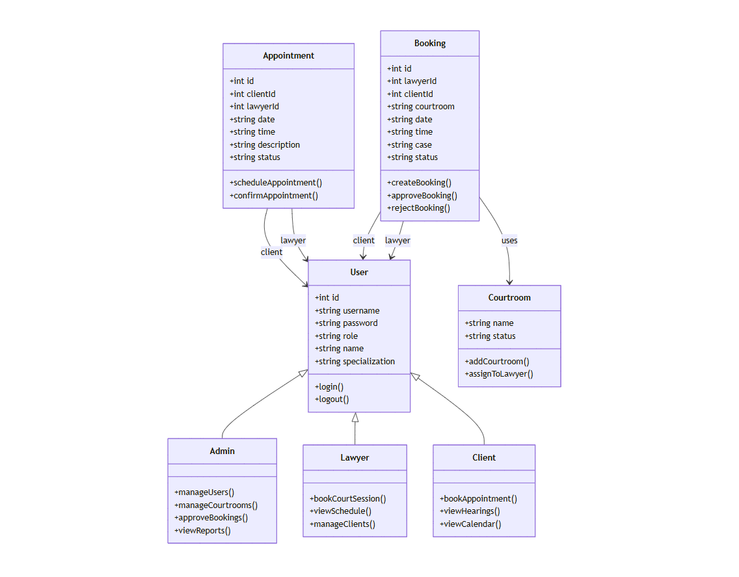

Fig : 4.1 Uml Class Diagram
The class diagram for the Virtual Legal Advisory and Case Management System illustrates the major entities and their interactions, capturing the structural design of the platform. At the core of the system is the User class, which represents the different actors in the system, including Admin, Lawyer, and Client. Each user has attributes such as id, username, password, role, name, and specialization, ensuring that the system can distinctly manage user identities and access rights. The operations login() and logout() define the authentication mechanism that allows users to securely enter and exit the system. The role-based structure ensures that each user interacts with the system according to their specific responsibilities, creating a clear separation of concerns.
The Appointment class handles the scheduling of consultations between clients and lawyers. With attributes like id, clientId, lawyerId, date, time, description, and status, it ensures proper tracking of every appointment. The methods scheduleAppointment() and confirmAppointment() enable clients to book meetings with lawyers and allow lawyers to validate or confirm them. This feature is crucial for providing organized and structured communication within the platform. The association between Appointment and User ensures that appointments are always tied to a specific client and lawyer, maintaining accountability and traceability.
The Booking class extends functionality beyond basic appointments by managing courtroom-related activities and case hearings. It includes attributes such as id, lawyerId, clientId, courtroom, date, time, case, and status. The methods createBooking(), approveBooking(), and rejectBooking() ensure that the booking lifecycle is properly managed from initiation to approval or rejection. By linking directly to both lawyers and clients, the Booking class ensures transparency and real-time updates regarding case proceedings, while maintaining secure case assignments.

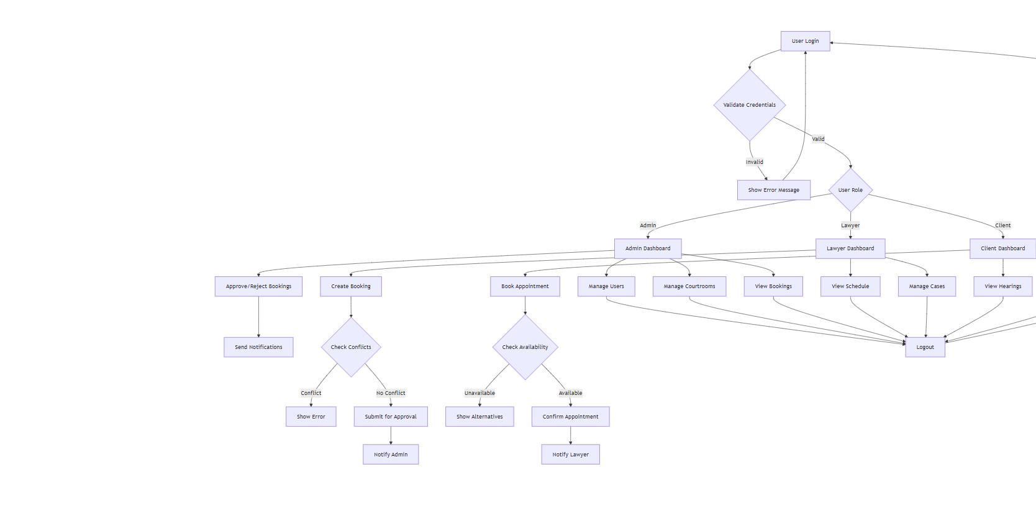

Fig : 4.2 Flow Chart Diagram

The flow of the Virtual Legal Advisory and Case Management System begins with the User Login process. Every user—whether an admin, lawyer, or client—must first enter their credentials. The system then performs a validation check to verify the provided credentials. If the credentials are invalid, the system immediately returns an error message and denies access. However, if the login is successful, the system checks the User Role to determine the type of user accessing the application. This role-based access ensures that admins, lawyers, and clients each receive a customized dashboard with only the functionalities relevant to them.
When an Admin logs in, they are directed to the Admin Dashboard, where they can perform a variety of management tasks. The admin has access to critical modules such as Manage Users, Manage Courtrooms, and Approve or Reject Bookings. Additionally, admins are responsible for creating bookings when necessary, approving case-related activities, and monitoring courtroom schedules. Before approving a booking, the system performs a conflict check to ensure that no overlapping schedules or courtroom clashes exist. If a conflict is detected, the system raises an error or prompts the admin with details of the conflict. If no conflict exists, the booking request is submitted for approval, and the concerned admin is notified. Once the approval or rejection process is complete, the system automatically sends notifications to all concerned parties.
On the other hand, when a Lawyer logs in, they are redirected to the Lawyer Dashboard, where they can view and manage their Schedule, track Bookings, and oversee Cases. Lawyers are primarily responsible for reviewing assigned clients, monitoring courtroom sessions, and confirming appointments. The dashboard provides them with clear visibility of their daily, weekly, or monthly commitments, thereby reducing scheduling conflicts and enhancing efficiency. The integration of automated notifications further ensures that lawyers remain updated regarding any changes made by admins or clients.

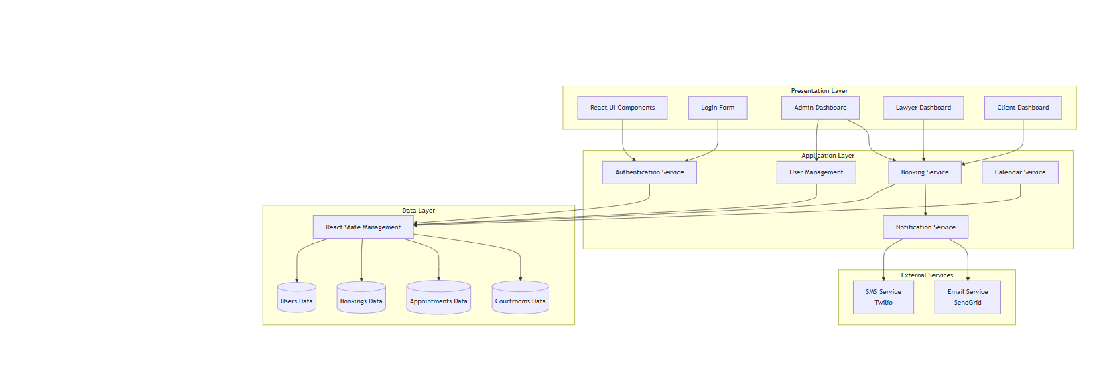
Fig : 4.3 Architecture Diagram

The architecture of the Virtual Legal Advisory and Case Management System is designed as a multi-layered structure, ensuring modularity, scalability, and ease of maintenance. At the top of the structure lies the Presentation Layer, which provides the user interface and interaction components. This layer includes essential modules such as React UI Components, Login Form, Admin Dashboard, Lawyer Dashboard, and Client Dashboard. The presentation layer acts as the primary entry point for all users, ensuring that each role is provided with a customized and role-specific interface. For instance, the admin dashboard allows administrators to manage users and courtrooms, the lawyer dashboard provides tools to handle bookings and case schedules, and the client dashboard enables clients to book appointments and track hearings. By separating presentation concerns, the system ensures a seamless and intuitive user experience while maintaining flexibility for future enhancements.
Beneath the presentation layer lies the Application Layer, which contains the core business logic and functional services of the system. This layer integrates multiple services that work in coordination to deliver the platform’s features. The Authentication Service is responsible for validating user credentials during the login process, ensuring that only authorized individuals gain access to the system. The User Management Service handles operations related to user creation, role assignment, and profile management, making sure that different access levels are maintained for admins, lawyers, and clients. The Booking Service forms the backbone of the system, allowing clients to schedule appointments, lawyers to confirm them, and admins to approve or reject courtroom requests after conflict checks. Similarly, the Calendar Service ensures that all appointments, hearings, and schedules are maintained in an organized manner, reducing overlaps and improving efficiency. The Notification Service is another critical component, ensuring that all users are informed in real-time about approvals, rejections, scheduling updates, or courtroom conflicts.

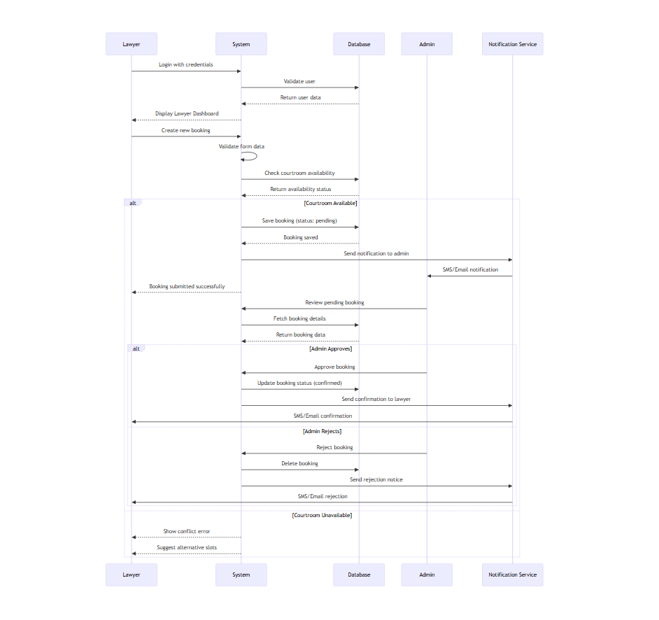
Fig : 4.4 Sequence Diagram

The sequence diagram provides a detailed view of how different components and actors interact in the booking process of the Virtual Legal Advisory and Case Management System. It focuses on the step-by-step flow of events starting from the lawyer initiating a booking to the final confirmation or rejection, along with notifications being sent to the concerned parties.
The process begins when a lawyer logs in with their credentials. The system validates these credentials against the stored records in the database. Once verified, the system retrieves the corresponding user data and displays the lawyer dashboard, allowing the lawyer to proceed with further actions. This authentication step ensures that only authorized users gain access to the system, thereby safeguarding the data and features specific to each role.
After logging in, the lawyer proceeds to create a new booking request. The system validates the submitted form data to ensure completeness and correctness. Once validated, the system queries the database to check courtroom availability for the requested slot. The database then returns the availability status, which determines the next step in the sequence. If the courtroom is available, the booking request is saved in the database with a pending status. The system then notifies the admin about the new booking request while simultaneously sending a notification (via SMS or email) using the notification service to confirm that the request has been successfully submitted.

CHAPTER – V
IMPLEMENTATION AND TESTING

The implementation of the Virtual Legal Advisory and Case Management System was carried out in a structured and modular way to ensure scalability, maintainability, and ease of integration. The system was built using the MERN stack (MongoDB, Express.js, React.js, and Node.js), which provides a robust environment for developing full-stack web applications. The choice of this stack enabled seamless communication between the frontend and backend, as well as efficient handling of large amounts of legal case and appointment data.
At the frontend, React.js was used to design dynamic and interactive user interfaces for clients, lawyers, and administrators. The component-based architecture of React allowed reusability of modules such as login forms, booking dashboards, appointment calendars, and notification panels. React state management was used to track user sessions and display real-time updates on appointments, bookings, and case progress.
The backend was implemented using Node.js with Express.js as the web framework. Express.js was responsible for defining routes for user authentication, booking creation, appointment scheduling, and courtroom management. The backend was designed to be RESTful, ensuring a standardized way for the frontend to communicate with the server using JSON APIs. Sensitive operations such as login and booking approvals were secured using JWT (JSON Web Token) for authentication and authorization.
For the database, MongoDB was chosen due to its flexibility in handling unstructured and semi-structured legal data. Collections were created for users, appointments, bookings, and courtrooms, each with specific attributes defined in the entity-relationship design. This schema-less database structure provided adaptability for future enhancements, such as storing digital evidence or case documents. Indexing and query optimization techniques were applied to ensure efficient retrieval of appointment and booking data.
An important aspect of implementation was real-time communication and notifications. Using third-party services such as Twilio for SMS notifications and SendGrid for email services, users were instantly informed about booking confirmations, rejections, or appointment reminders. This ensured that no stakeholder missed important legal updates.
The admin dashboard was designed to provide administrators with complete control over the system. From here, admins could manage users, approve or reject bookings, allocate courtrooms, and generate activity reports. Lawyers were provided with a dashboard to view their upcoming hearings, manage client appointments, and track schedules. Clients, on the other hand, could easily book appointments, upload documents, and check the status of their cases.
The implementation also focused on error handling and conflict resolution. For instance, when a courtroom booking request clashed with an existing session, the system displayed an error message and suggested alternative slots. This ensured smooth scheduling and minimized disputes.
Overall, the implementation ensured that all modules — authentication, booking, appointments, courtroom allocation, and notifications — worked together as a cohesive platform to provide an efficient, user-friendly, and secure legal advisory and case management system.

TESTING

Testing played a crucial role in ensuring the reliability, functionality, and security of the Virtual Legal Advisory and Case Management System. Once the system was implemented, it was subjected to multiple layers of testing to validate its performance under different conditions. The process began with unit testing, where each individual component of the application such as user authentication, booking creation, appointment scheduling, and notification services was tested in isolation. Automated testing frameworks like Jest and Mocha were used to simulate different input and output scenarios, ensuring that each module performed as expected without errors. For example, the login feature was tested with valid and invalid credentials to confirm that authentication mechanisms worked correctly and that unauthorized users were denied access. Similarly, the booking module was tested to verify that appointments were created, approved, and rejected according to predefined rules.
After unit testing, the system underwent integration testing to verify that all modules functioned seamlessly when combined. This stage ensured that data flow between the user interface, backend services, and the database was accurate and reliable. For instance, when a client submitted a booking request, the process was validated to ensure that it passed from the frontend to the backend, was stored in MongoDB, forwarded to the admin for approval, and finally triggered an SMS or email notification. Any discrepancies between module interactions were identified and resolved at this stage to guarantee smooth system integration.
The next phase was system testing, where the application was tested as a whole in a simulated production environment. Here, the primary goal was to validate all functional and non-functional requirements. During system testing, the platform was evaluated for responsiveness, usability, and correctness across different devices and browsers. Performance testing was also carried out to determine how the system behaved under heavy loads, such as multiple users attempting to log in or book appointments at the same time. Stress testing was performed by deliberately pushing the system beyond its normal operating limits to identify any potential breakdowns or bottlenecks. These tests ensured that the system was robust enough to handle real-world usage.
Another important stage was user acceptance testing (UAT). Lawyers, clients, and administrators were invited to interact with the system in real-world scenarios to validate its usability and efficiency. Their feedback was collected on ease of navigation, clarity of instructions, response times, and overall satisfaction. Based on their suggestions, adjustments were made to simplify workflows, improve the design of the dashboards, and optimize the notification process. This phase confirmed that the system met user expectations and delivered value in streamlining legal advisory and case management processes.
Special attention was also given to security testing, as the system handles sensitive client and legal data. The application was tested for vulnerabilities such as SQL injection, cross-site scripting (XSS), and brute-force attacks on login endpoints. JSON Web Tokens (JWT) were verified to ensure they expired after a session timeout, preventing unauthorized access. Encrypted communication using SSL/TLS was also tested to guarantee that all sensitive data, including case files and user credentials, was securely transmitted. Finally, regression testing was carried out whenever new features such as conflict resolution or document uploads were introduced, to ensure that existing features like appointment booking and notifications remained unaffected.

CHAPTER – VI
RESULTS

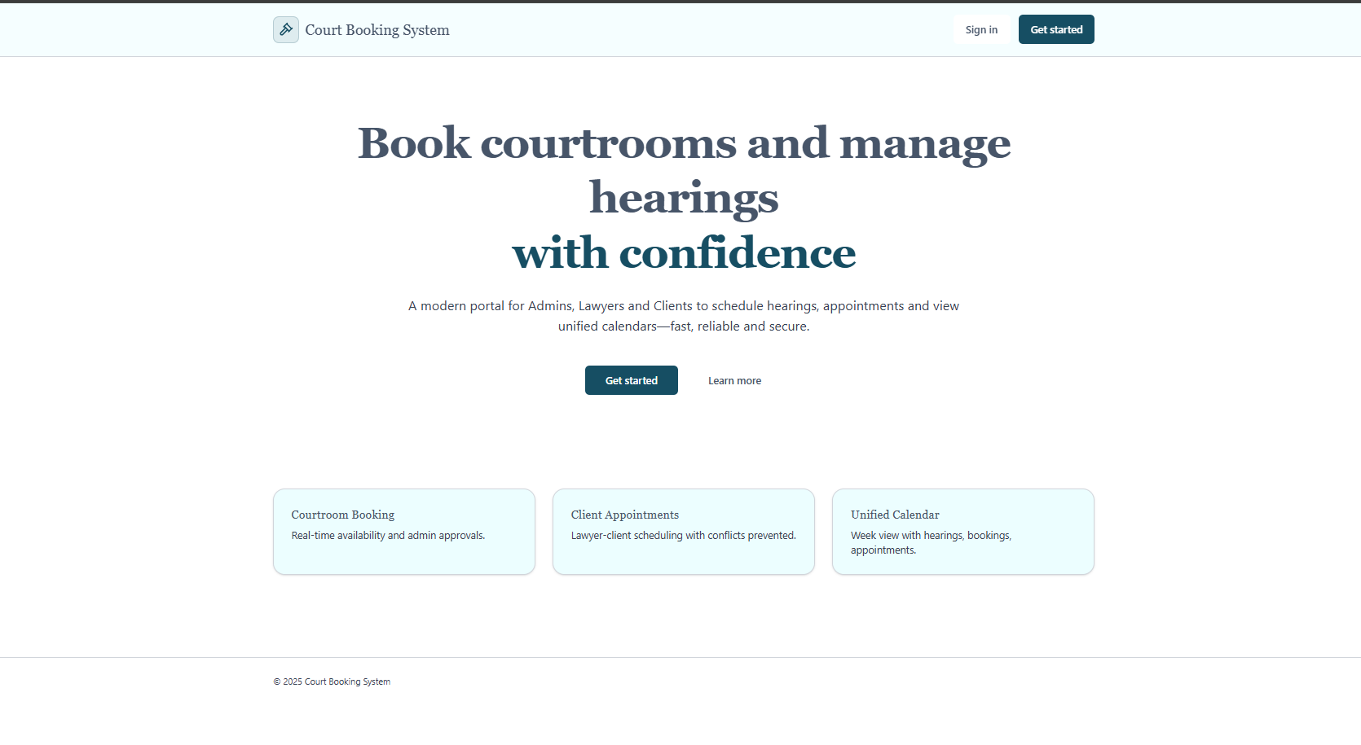

Fig : 6.1 Court Booking System

This screen represents the homepage of the Court Booking System, which introduces the platform’s purpose and key functionalities in a clear and professional manner. The main heading highlights the system’s core objective—to enable courtroom bookings and hearing management with confidence—which reassures users about the reliability and security of the platform. Below this, the description emphasizes that it is a modern digital portal designed for admins, lawyers, and clients to streamline the scheduling of hearings and appointments while also providing access to unified calendars. The language used conveys trust, efficiency, and convenience, making it appealing to legal professionals and clients alike.
The interface prominently displays a “Get Started” button at the center, encouraging new users to begin exploring the system, while a “Sign In” option at the top ensures that existing users can easily log in to their accounts. This dual option balances accessibility for both new and returning users. Additionally, a “Learn more” link is provided for users who want to understand the platform’s offerings before committing to registration or usage.
The page also highlights the three major services offered by the system in dedicated sections: Courtroom Booking, which ensures real-time availability and admin approvals for efficient scheduling; Client Appointments, which allows lawyers and clients to schedule consultations without conflicts; and a Unified Calendar, which consolidates hearings, bookings, and appointments into a single view for better time management. These features are presented in a minimal and user-friendly layout, ensuring that users quickly grasp the key benefits of the system.

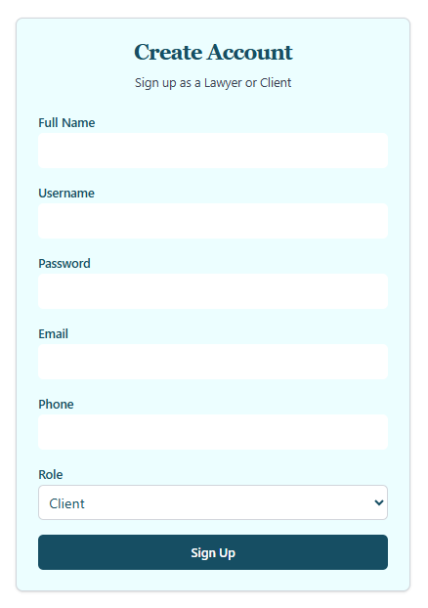

Fig : 6.2 Court Booking System

This image shows a straightforward web page for creating a new user account. The main heading, "Create Account," is clearly displayed at the top, followed by a smaller subheading that specifies the purpose: "Sign up as a Lawyer or Client." The form itself is designed with several input fields, each with a clear label to guide the user. These fields, from top to bottom, are for the user's Full Name, Username, Password, Email, and Phone number. Each field is represented by a blank, elongated box, inviting the user to type in their information. Below the standard text input fields, there is a dropdown menu for "Role," which allows the user to select whether they want to register as a Lawyer or a Client; the menu is currently set to "Client." The form is finalized with a prominent, dark-colored button labeled "Sign Up," which serves as the call to action for the user to submit their registration details. The entire page has a clean, professional aesthetic, featuring a light blue background and white input fields, ensuring the form is easy to read and navigate.
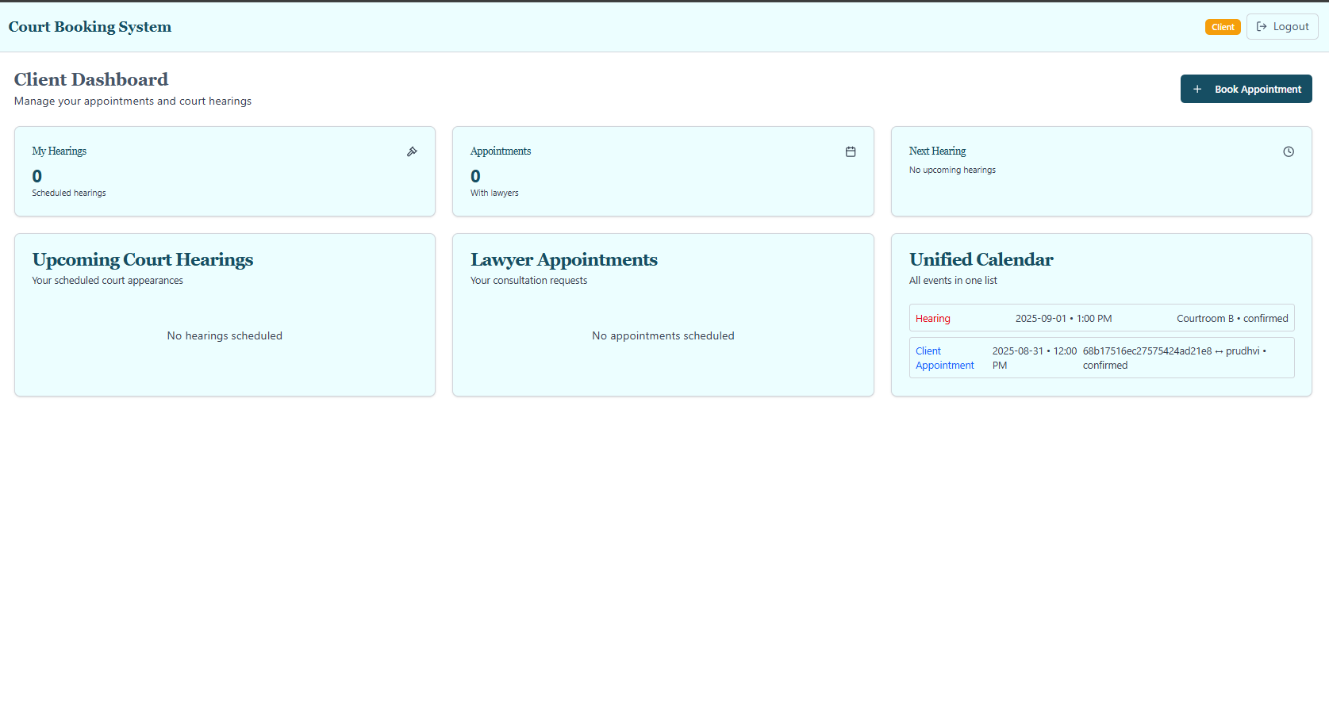

Fig : 6.3 Court Booking System

This image presents the comprehensive Client Dashboard for a Court Booking System, a user interface designed to give clients a unified and organized view of their legal-related activities. Upon logging in, the user is greeted with a clean and professional layout, featuring the main title "Client Dashboard" and the purpose statement, "Manage your appointments and court hearings." The top right corner of the screen confirms the user's role as a "Client" and provides a convenient "Logout" button.
The dashboard is composed of several modular widgets, each serving a specific function. At the top, three smaller panels provide quick summaries: "My Hearings" and "Appointments" both show a count of 0, indicating no scheduled events, while a third panel, "Client Hearing," explicitly states there are no upcoming hearings. These summary boxes offer an at-a-glance overview of the client's current status.
Below these summaries, the dashboard provides more detailed information in two larger sections: "Upcoming Court Hearings" and "Lawyer Appointments." Both of these sections currently state "No hearings scheduled" and "No appointments scheduled," respectively, reinforcing the information from the summary panels. The right side of the screen features a highly useful "Unified Calendar" which aggregates all events into a single, easy-to-read list. This calendar shows two confirmed entries: a "Hearing" scheduled for September 1, 2025, at 1:00 PM in Courtroom B, and a "Client Appointment" for August 31, 2025, at 12:00 PM. This consolidated view is a key feature for preventing scheduling conflicts and keeping track of all confirmed events. Additionally, a prominent blue button labeled "+ Book Appointment" is strategically placed on the top right, providing an immediate call to action for the client to schedule new events as needed.

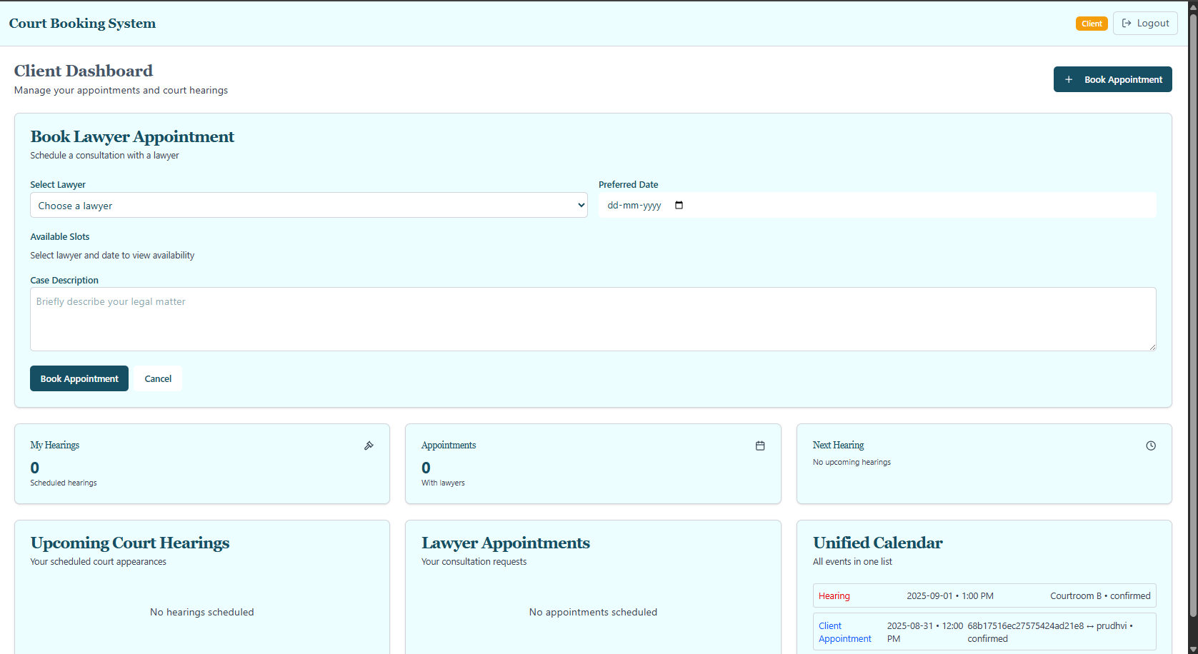

Fig : 6.4 Court Booking System

This image provides a detailed view of the "Book Lawyer Appointment" feature within a client's dashboard of a Court Booking System. The primary focus is a large form designed to facilitate a consultation booking with a lawyer. The form is clearly titled, with the subheading "Schedule a consultation with a lawyer," guiding the user through the necessary steps. The fields include a dropdown menu to "Select Lawyer," a calendar field to choose a "Preferred Date" (formatted as dd-mm-yyyy), and a section designated for showing "Available Slots" once a lawyer and date are selected. A significant portion of the form is a large text box for the user to provide a "Case Description," with the prompt, "Briefly describe your legal matter," allowing the client to provide context for their appointment. At the bottom of this booking form are two buttons: a prominent blue "Book Appointment" button to finalize the request and a "Cancel" button to discard the input.
Below this main booking interface, the page retains the client dashboard layout seen in the previous image, reinforcing its purpose. This lower section acts as a quick-reference summary, showing panels for "My Hearings" and "Appointments," both of which show a count of 0. The "Upcoming Court Hearings" and "Lawyer Appointments" sections also explicitly state that no events are scheduled. The final, and arguably most useful, panel is the "Unified Calendar," which provides a consolidated list of all confirmed events, including a "Hearing" for September 1, 2025, and a "Client Appointment" for August 31, 2025. This cohesive design allows the client to both schedule new appointments and immediately see their impact on their overall legal calendar without navigating away from the page.

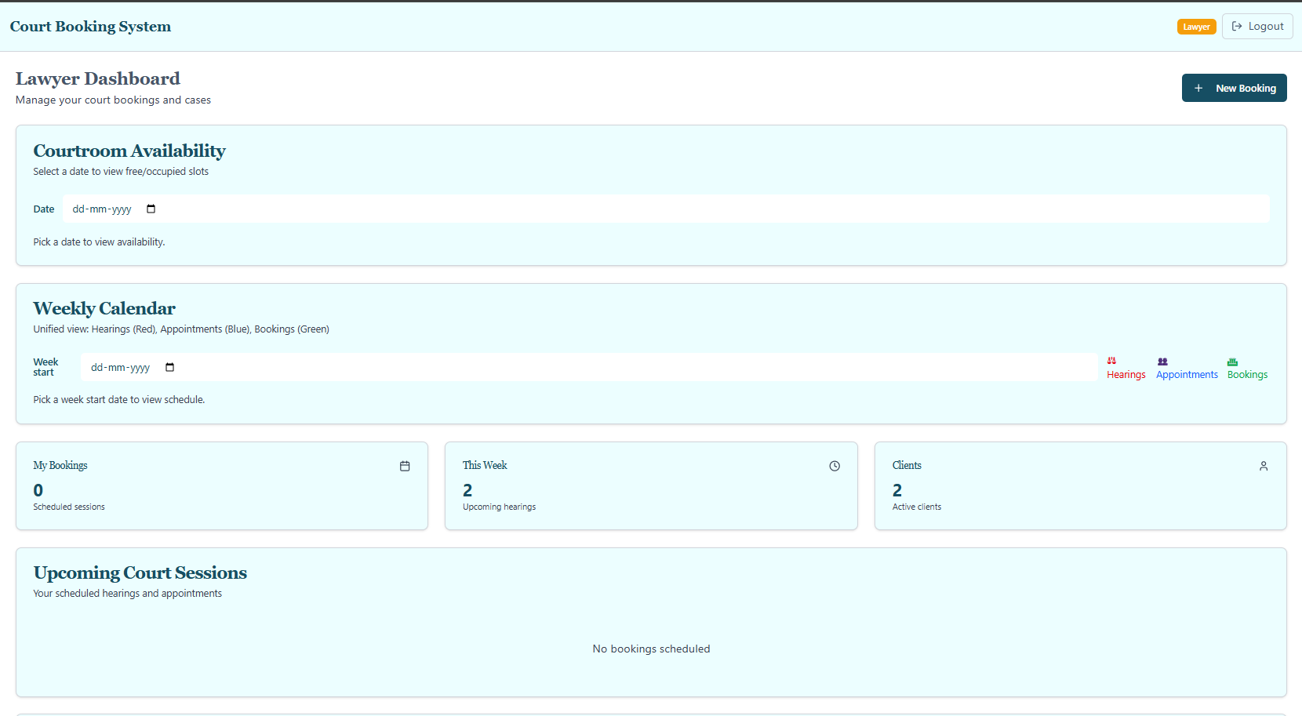

Fig : 6.5 Court Booking System

This image presents the comprehensive Lawyer Dashboard for a Court Booking System, a user interface specifically designed to help legal professionals efficiently manage their court-related activities. The top of the page confirms the user's role as a "Lawyer" and provides a convenient "Logout" button. The dashboard is structured into several sections, offering both a broad overview and specific tools for scheduling. The first major section, "Courtroom Availability," is a practical tool that allows the lawyer to check free and occupied slots by simply selecting a date. Below this, the "Weekly Calendar" provides a crucial visual aid, offering a unified view of all scheduled events. This calendar uses a color-coding system to differentiate between Hearings (in red), Appointments (in blue), and Bookings (in green), which helps the user quickly grasp their weekly schedule by selecting a "Week start" date.
Further down the page, three summary widgets offer quick, at-a-glance information. "My Bookings" shows a current count of 0 scheduled sessions, while "This Week" highlights 2 upcoming hearings, indicating a disparity that might require further investigation by the user. The "Clients" widget shows that the lawyer has 2 active clients. Finally, a dedicated section titled "Upcoming Court Sessions" serves as a consolidated list of all scheduled hearings and appointments. Although it currently states "No bookings scheduled," this panel is designed to provide a complete view of the lawyer's commitments. A prominent "+ New Booking" button is also strategically placed at the top right, providing an easy and immediate way for the lawyer to add new entries to their schedule. The clean layout and integrated features make this dashboard a central hub for a lawyer to manage their professional calendar.
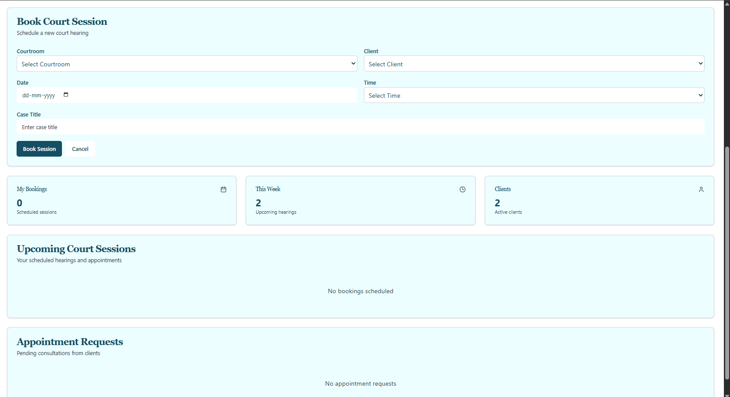

Fig : 6.6 Court Booking System

This image displays a lawyer's interface for the Court Booking System, specifically showing the "Book Court Session" feature. The primary function of this page is to allow the lawyer to schedule a new court hearing. The top section is a form with several key fields. The lawyer can select a "Courtroom" and a "Client" from two separate dropdown menus. They can also specify the "Date" and "Time" of the hearing using dedicated input fields. Additionally, there is a field to enter a "Case Title" to identify the specific legal matter. Below these fields are two buttons, a blue "Book Session" button to confirm the booking and a "Cancel" button to discard the information.
The lower half of the page provides a summary of the lawyer's professional schedule, similar to a dashboard. It includes three summary widgets: "My Bookings," which shows 0 scheduled sessions; "This Week," which shows 2 upcoming hearings; and "Clients," which indicates 2 active clients. Below these widgets, a larger section titled "Upcoming Court Sessions" currently states, "No bookings scheduled." Finally, there is a new section titled "Appointment Requests" that shows "No appointment requests" are pending, suggesting this is where a lawyer would view consultation requests from clients. This integrated design allows the lawyer to not only schedule new sessions but also quickly check their current workload and pending requests all on a single page.

CHAPTER - VII
CONCLUSION

The Court Booking System represents a significant advancement in the digital transformation of legal services by providing a centralized and efficient platform for managing courtroom reservations, client appointments, and legal proceedings. Traditional methods of courtroom scheduling often rely on manual processes, physical paperwork, or fragmented communication channels, which frequently lead to double bookings, missed hearings, and delays in case proceedings. This project addresses these challenges by introducing a robust online system that ensures transparency, accessibility, and streamlined coordination among administrators, lawyers, and clients.
The system’s core functionalities—including real-time courtroom booking, lawyer-client appointment management, and a unified calendar view—demonstrate how technology can simplify complex workflows within the judicial ecosystem. By automating scheduling and reducing human intervention, the platform minimizes errors while simultaneously enhancing productivity. Lawyers benefit from easier appointment management and better time allocation, clients gain faster access to legal consultations, and administrators maintain greater control over courtroom availability, ensuring optimal utilization of resources.
Another noteworthy contribution of this system is its ability to foster trust and confidence among users by ensuring secure data handling, transparent booking approvals, and conflict-free scheduling. It has been designed with scalability in mind, making it adaptable for both small law firms and large judicial institutions. Furthermore, the integration of a user-friendly interface makes it accessible even to individuals with limited technical expertise, thereby broadening its adoption potential.

CHAPTER - VIII
FUTURE SCOPE

The Court Booking System, while already addressing major challenges in courtroom and appointment management, has vast potential for further expansion and enhancement to make it even more comprehensive and impactful. As the legal sector increasingly embraces digital transformation, there is scope to integrate advanced technologies and broaden the system’s functionalities to better serve administrators, lawyers, and clients alike. One of the most promising future enhancements is the integration of Artificial Intelligence (AI) and Machine Learning (ML) to enable intelligent scheduling and conflict prediction. For example, AI could analyze historical booking patterns, lawyer availability, and case urgency to automatically suggest the most suitable time slots for hearings and consultations, thereby reducing scheduling delays and enhancing efficiency.
Another important area of development lies in mobile application support. With the increasing reliance on smartphones, a mobile-friendly version or dedicated app would allow lawyers, clients, and administrators to access the system on the go, receive instant notifications about hearings or appointment updates, and manage their schedules more flexibly. The system can also be integrated with cloud infrastructure, enabling seamless scalability and ensuring secure data storage with minimal downtime. This would be especially beneficial for large-scale adoption across multiple courts or judicial institutions where thousands of users need to access the platform simultaneously.
In terms of user experience, the system can incorporate multi-language support and voice-based interactions to cater to a wider audience, especially in countries with diverse linguistic populations. Enhanced data analytics and reporting features could provide insights into courtroom utilization, lawyer performance, and case trends, helping both administrators and legal authorities make informed decisions. Additionally, future versions can include video conferencing and remote hearing capabilities, ensuring that clients and lawyers can connect virtually when physical appearances are not possible, which became especially relevant in the post-pandemic era.

CHAPTER – IX
APPENDIX

import React from "react"
import { Slot } from "@radix-ui/react-slot"
import { cva } from "class-variance-authority"
import { cn } from "../../lib/utils"

const badgeVariants = cva(
"inline-flex items-center rounded-md border px-2 py-0.5 text-xs font-medium w-fit whitespace-nowrap shrink-0 [&>svg]:size-3 gap-1 [&>svg]:pointer-events-none focus-visible:border-ring focus-visible:ring-ring/50 focus-visible:ring-[3px] aria-invalid:ring-destructive/20 dark:aria-invalid:ring-destructive/40 aria-invalid:border-destructive transition-[color,box-shadow] overflow-hidden",
{
variants: {
variant: {
default: "border-transparent bg-primary text-primary-foreground shadow hover:bg-primary/80",
secondary: "border-transparent bg-secondary text-secondary-foreground hover:bg-secondary/80",
destructive: "border-transparent bg-destructive text-destructive-foreground shadow hover:bg-destructive/80",
outline: "text-foreground",
},
},
defaultVariants: {
variant: "default",
},
}
)

function Badge({ className, variant, ...props }) {
return (
<div className={cn(badgeVariants({ variant }), className)} {...props} />
)
}

export { Badge, badgeVariants }

import React from "react"
import { Slot } from "@radix-ui/react-slot"
import { cva } from "class-variance-authority"
import { cn } from "../../lib/utils"

const buttonVariants = cva(
"inline-flex items-center justify-center gap-2 whitespace-nowrap rounded-md text-sm font-medium transition-all disabled:pointer-events-none disabled:opacity-50 [&_svg]:pointer-events-none [&_svg:not([class*='size-'])]:size-4 shrink-0 [&_svg]:shrink-0 outline-none focus-visible:border-ring focus-visible:ring-ring/50 focus-visible:ring-[3px] aria-invalid:ring-destructive/20 dark:aria-invalid:ring-destructive/40 aria-invalid:border-destructive",
{
variants: {
variant: {
default: "bg-primary text-primary-foreground hover:bg-primary/90",
destructive: "bg-destructive text-destructive-foreground hover:bg-destructive/90",
outline: "border border-input bg-background hover:bg-accent hover:text-accent-foreground",
secondary: "bg-secondary text-secondary-foreground hover:bg-secondary/80",
ghost: "hover:bg-accent hover:text-accent-foreground",
link: "text-primary underline-offset-4 hover:underline",
},
size: {
default: "h-10 px-4 py-2",
sm: "h-9 rounded-md px-3",
lg: "h-11 rounded-md px-8",
icon: "h-10 w-10",
},
},
defaultVariants: {
variant: "default",
size: "default",
},
}
)

const Button = React.forwardRef(({ className, variant, size, asChild = false, ...props }, ref) => {
const Comp = asChild ? Slot : "button"
return (
<Comp
className={cn(buttonVariants({ variant, size, className }))}
ref={ref}
{...props}
/>
)
})
Button.displayName = "Button"

export { Button, buttonVariants }

import React from "react"
import { cn } from "../../lib/utils"

const Card = React.forwardRef(({ className, ...props }, ref) => (
<div
ref={ref}
className={cn(
"rounded-lg border bg-card text-card-foreground shadow-sm",
className
)}
{...props}
/>
))
Card.displayName = "Card"

const CardHeader = React.forwardRef(({ className, ...props }, ref) => (
<div ref={ref} className={cn("flex flex-col space-y-1.5 p-6", className)} {...props} />
))
CardHeader.displayName = "CardHeader"

const CardTitle = React.forwardRef(({ className, ...props }, ref) => (
<h3
ref={ref}
className={cn(
"text-2xl font-semibold leading-none tracking-tight",
className
)}
{...props}
/>
))
CardTitle.displayName = "CardTitle"

const CardDescription = React.forwardRef(({ className, ...props }, ref) => (
<p
ref={ref}
className={cn("text-sm text-muted-foreground", className)}
{...props}
/>
))
CardDescription.displayName = "CardDescription"

const CardContent = React.forwardRef(({ className, ...props }, ref) => (
<div ref={ref} className={cn("p-6 pt-0", className)} {...props} />
))
CardContent.displayName = "CardContent"

const CardFooter = React.forwardRef(({ className, ...props }, ref) => (
<div ref={ref} className={cn("flex items-center p-6 pt-0", className)} {...props} />
))
CardFooter.displayName = "CardFooter"

export { Card, CardHeader, CardFooter, CardTitle, CardDescription, CardContent }

CHAPTER – X
REFRENCES

- Chukwuemeka, O., & Adepoju, O. (2020). Design and implementation of an online court case management system. International Journal of Computer Applications, 176(36), 1–7. https://doi.org/10.5120/ijca2020920183
- Gupta, A., & Yadav, R. (2021). E-court management system: A step towards digital judiciary. International Journal of Innovative Research in Computer and Communication Engineering, 9(3), 123–130.
- Odeh, A., & Al-Hasan, M. (2019). An automated scheduling system for courts using online booking platforms. Journal of Information Technology Research, 12(2), 45–58.
- Bhatia, P., & Jain, M. (2018). Online appointment scheduling systems: A comparative study. International Journal of Advanced Research in Computer Science, 9(5), 77–82.
- Adeyemi, T., & Oladipo, S. (2022). The role of technology in modernizing judicial processes: Case of e-court systems. African Journal of Computing & ICT, 15(1), 33–41.
- Sharma, K., & Mehta, A. (2020). Blockchain-based secure court record management system. IEEE Access, 8, 144123–144131. https://doi.org/10.1109/ACCESS.2020.3015099
- Agarwal, S., & Kumar, V. (2021). Artificial Intelligence in legal services: Opportunities and challenges. International Journal of Law and Technology, 13(2), 87–95.
- United Nations Office on Drugs and Crime (UNODC). (2020). E-justice: Digital solutions for courts. Retrieved from https://www.unodc.org/
- Ministry of Law & Justice, Government of India. (2019). E-Courts Project Phase II: Policy and Action Plan Document. Retrieved from https://doj.gov.in
- National Center for State Courts (NCSC). (2018). Trends in state courts: The future of court technology. Williamsburg, VA: NCSC Press.

